Design Idea #1
Date: 11/20/24
Description:pulley system powered by small electric motor which is powered by small solar panel, but sensors will tell when and how far the sheet needs to be pulled over the plant
Drawing that includes distinguishing information such as scale, dimensions, and materials: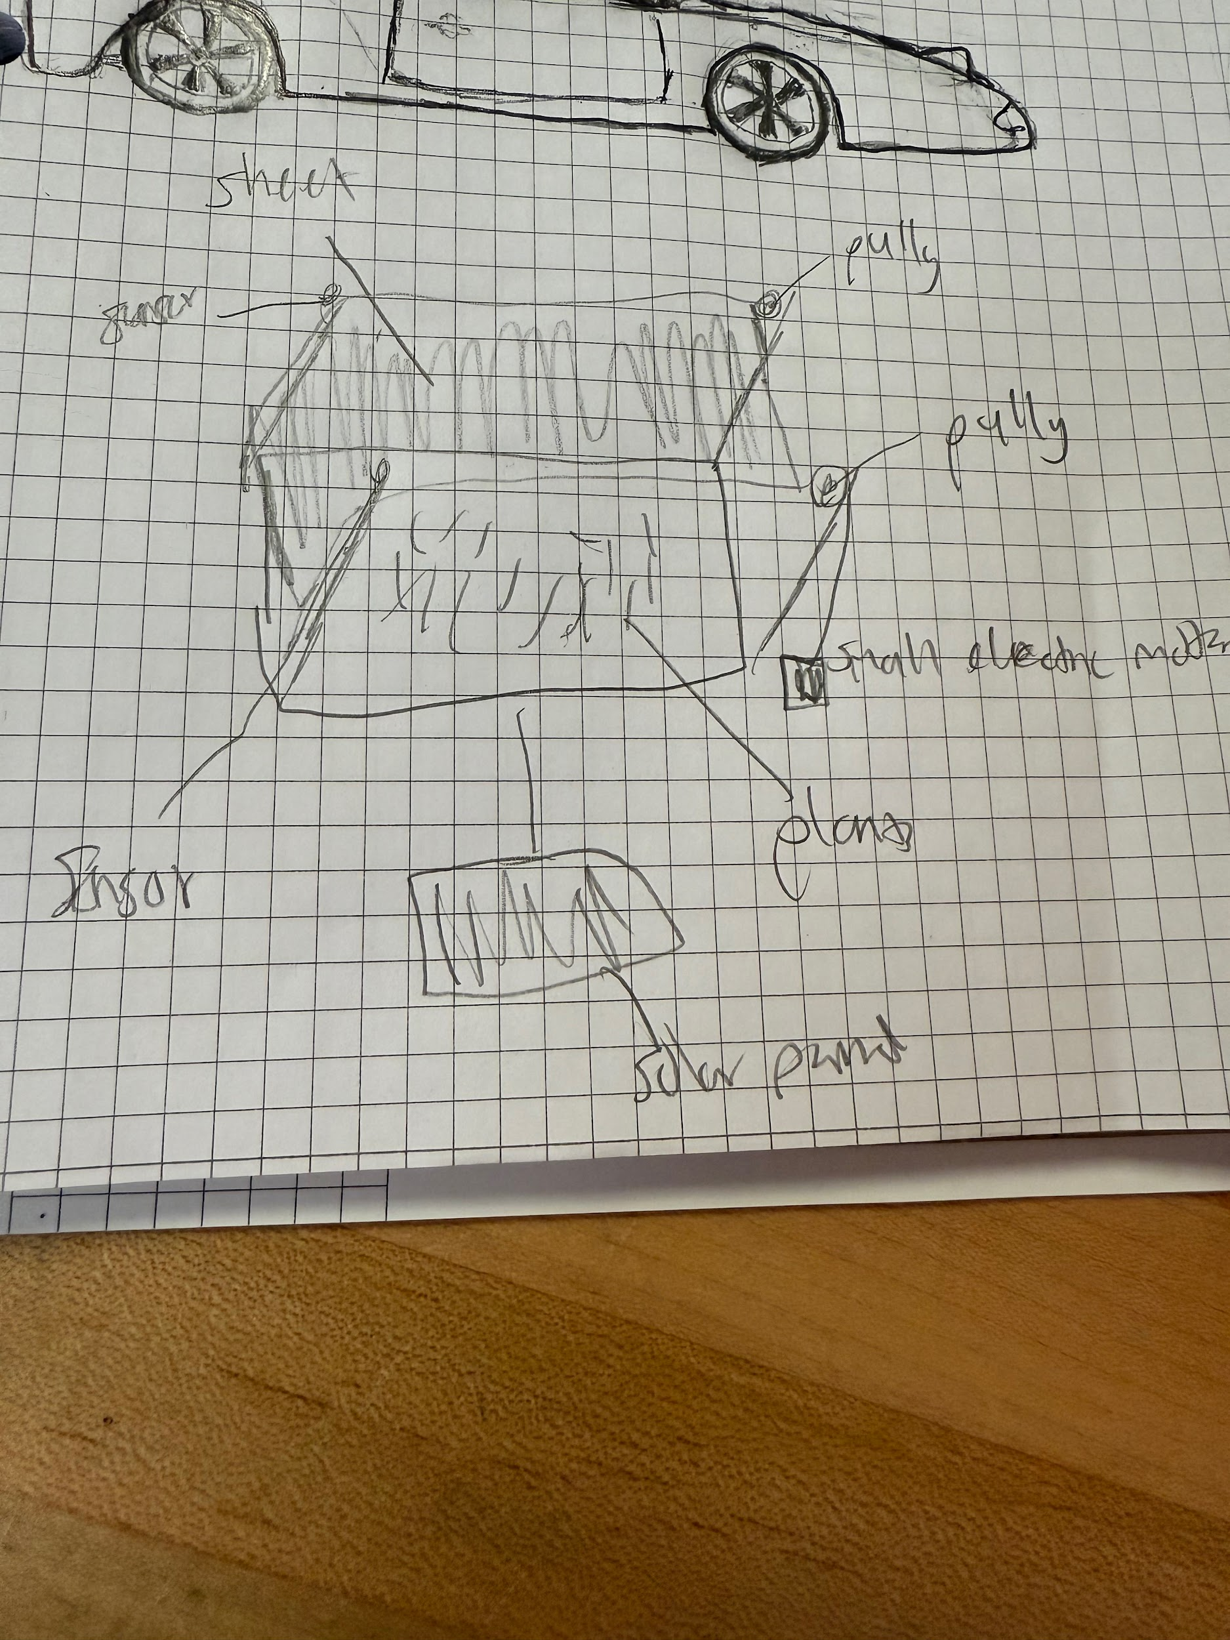Design Idea #2
Date:11/20
Description: It is a cart with a camper awning and it has our problem statement and base sketches.
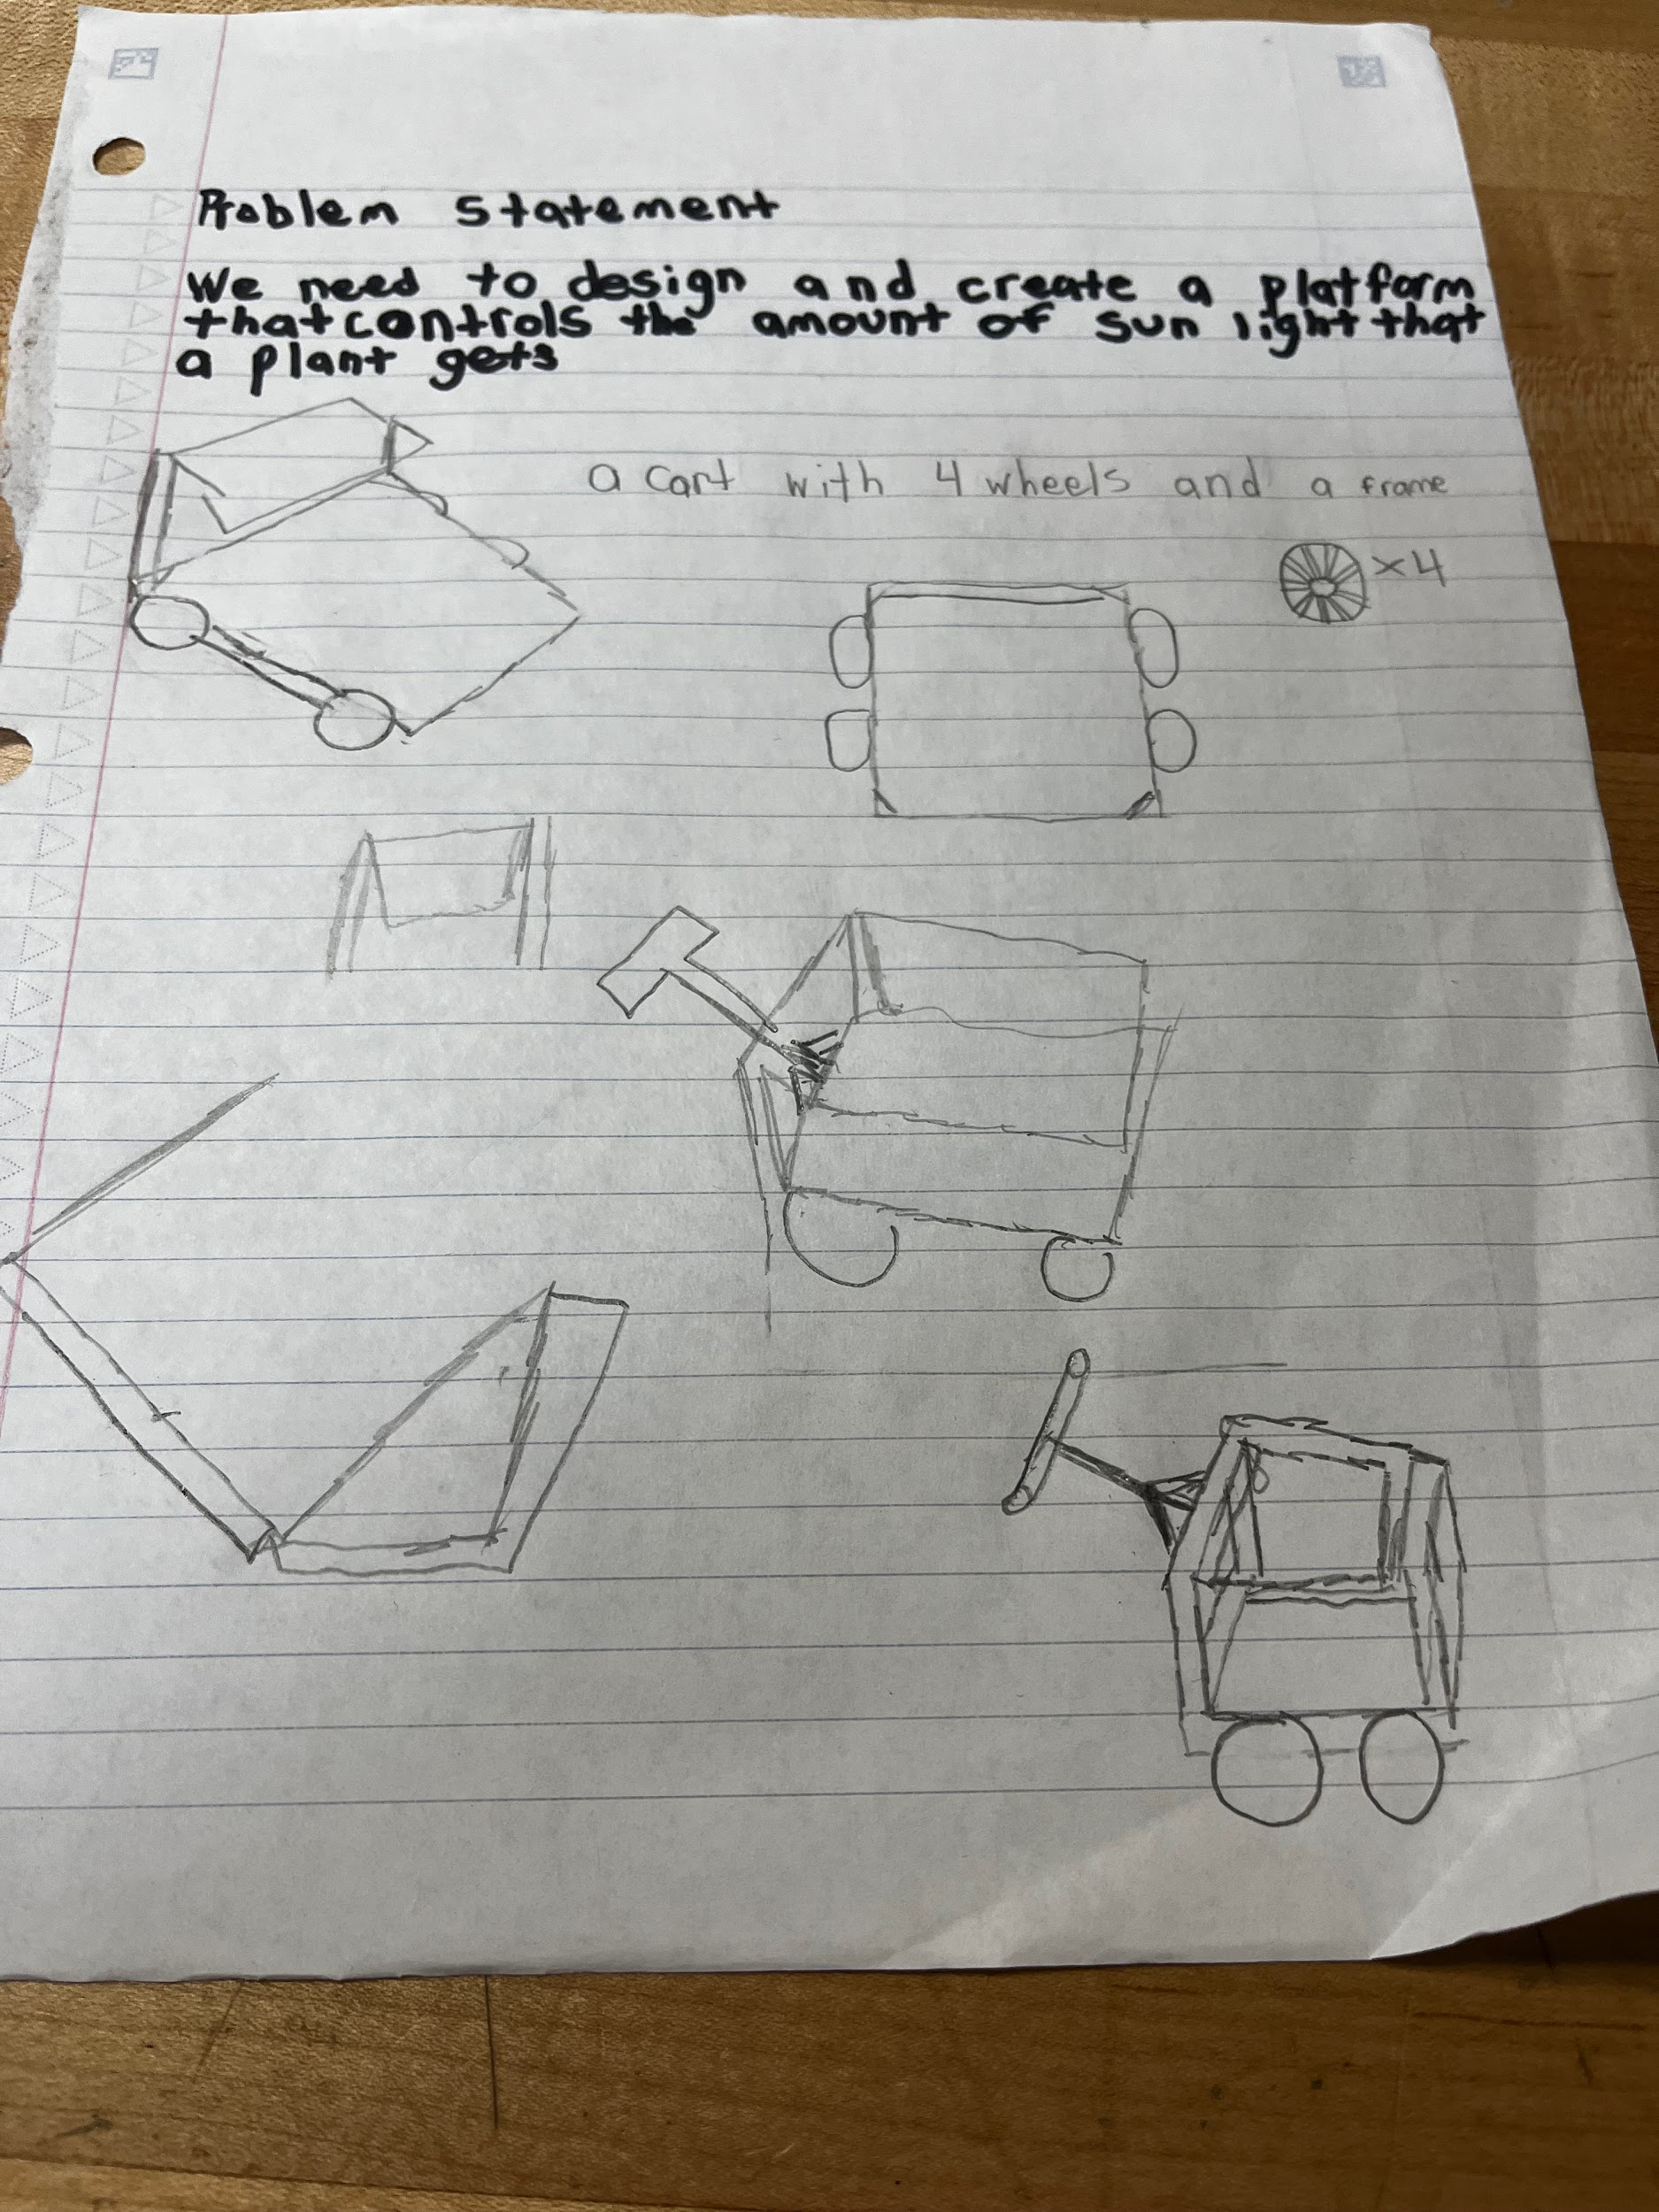
Design Idea #3
Date: 11/20
Description:
Drawing that includes distinguishing information such as scale, dimensions, and materials: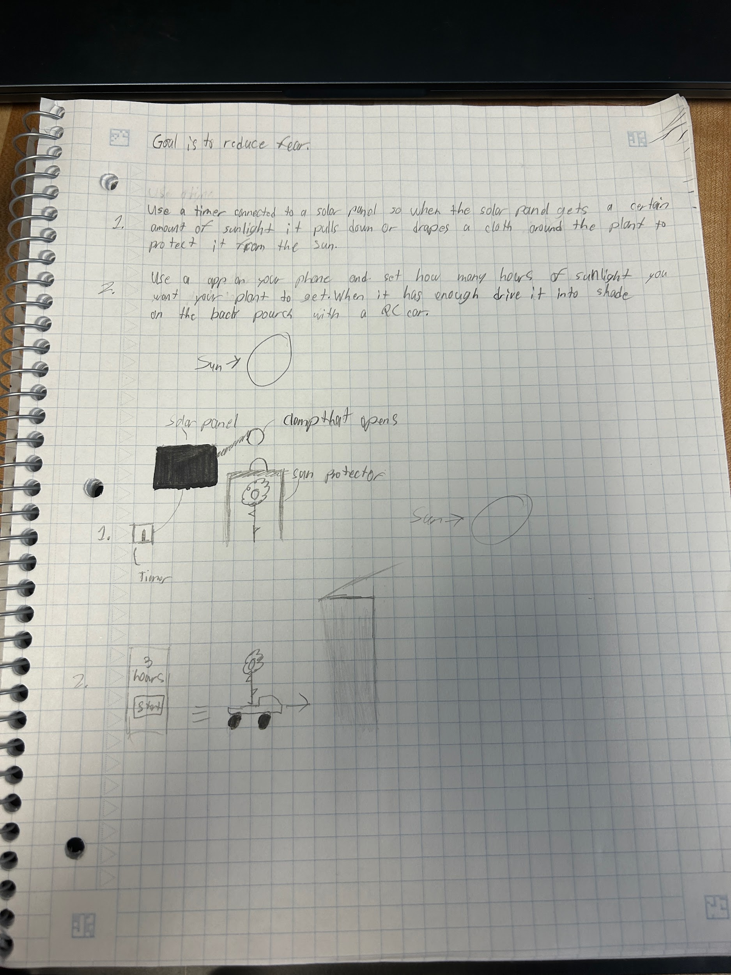
Design Idea #4
Date: 11/20/24
Description: We will have a pulley system that is powered by a motor (powered by a solar panel) and that motor gets its information from a sensor (on the roof) which detects the best time of day to move the shade screen from over the plant and once it gets all it needs it covers it back up.
Drawing that includes distinguishing information such as scale, dimensions, and materials:

Design Idea #5
Date:11/20/24
Description: Doors that are connected to cables and a pulley system close at a specific time you set with a clock/timer.This stops sunlight from getting to the plants.
Drawing that includes distinguishing information such as scale, dimensions, and materials: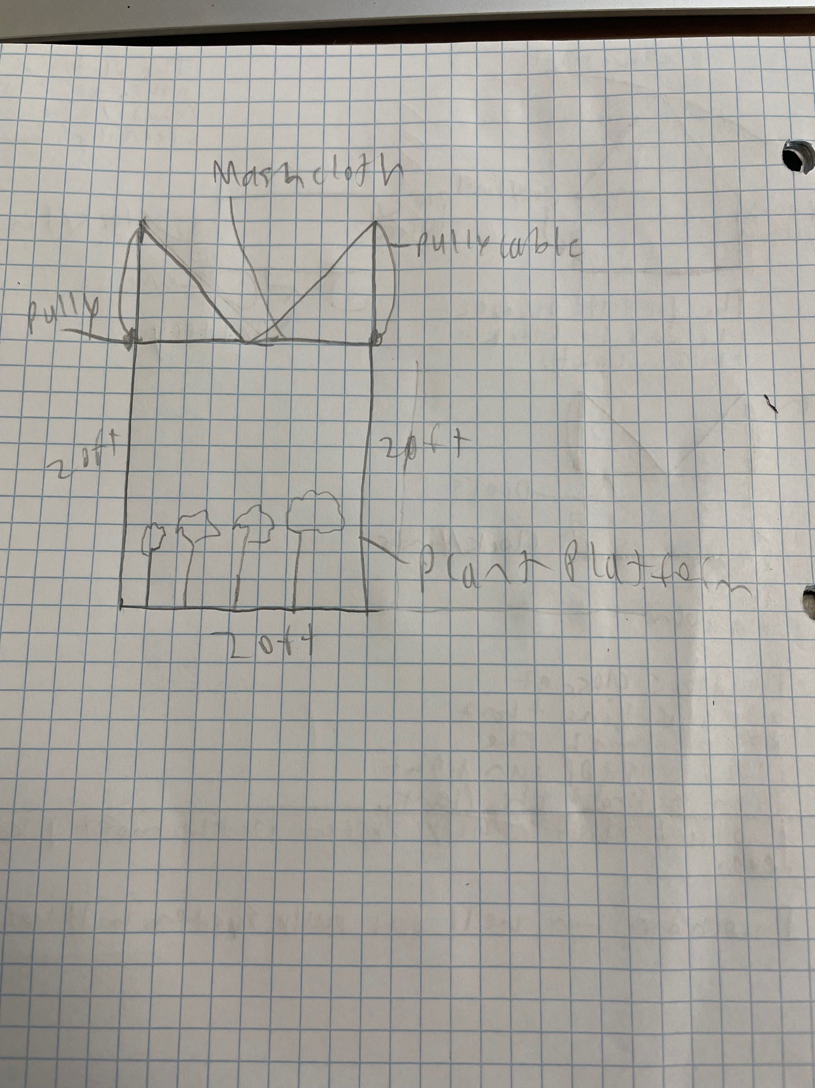

 | weight | Rewinding  motor | Mobile robot | Tilting sun shade | Plant cup cover
Cover multiple plants | 16% | 5 | 4 | 5 | 1
Easily put together | 14% | 3 | 3 | 4 | 5
Can control the sunlight | 25% | 5 | 5 | 4 | 5
Strong materials | 24% | 4 | 4 | 3 | 3
Cheap | 21% | 3 | 2 | 3 | 5
score | 100 | 4.06 | 3.7 | 3.71 | 3.88

The data chart shows us which of our designs was the best to pick for the following: covering multiple plants, can be easily put together, and can control sunlight, reliable, strong materials and still be cheap. The best design from our data was the pulley system design.
Design Blueprint #1
Date:12/4/24
Sketch: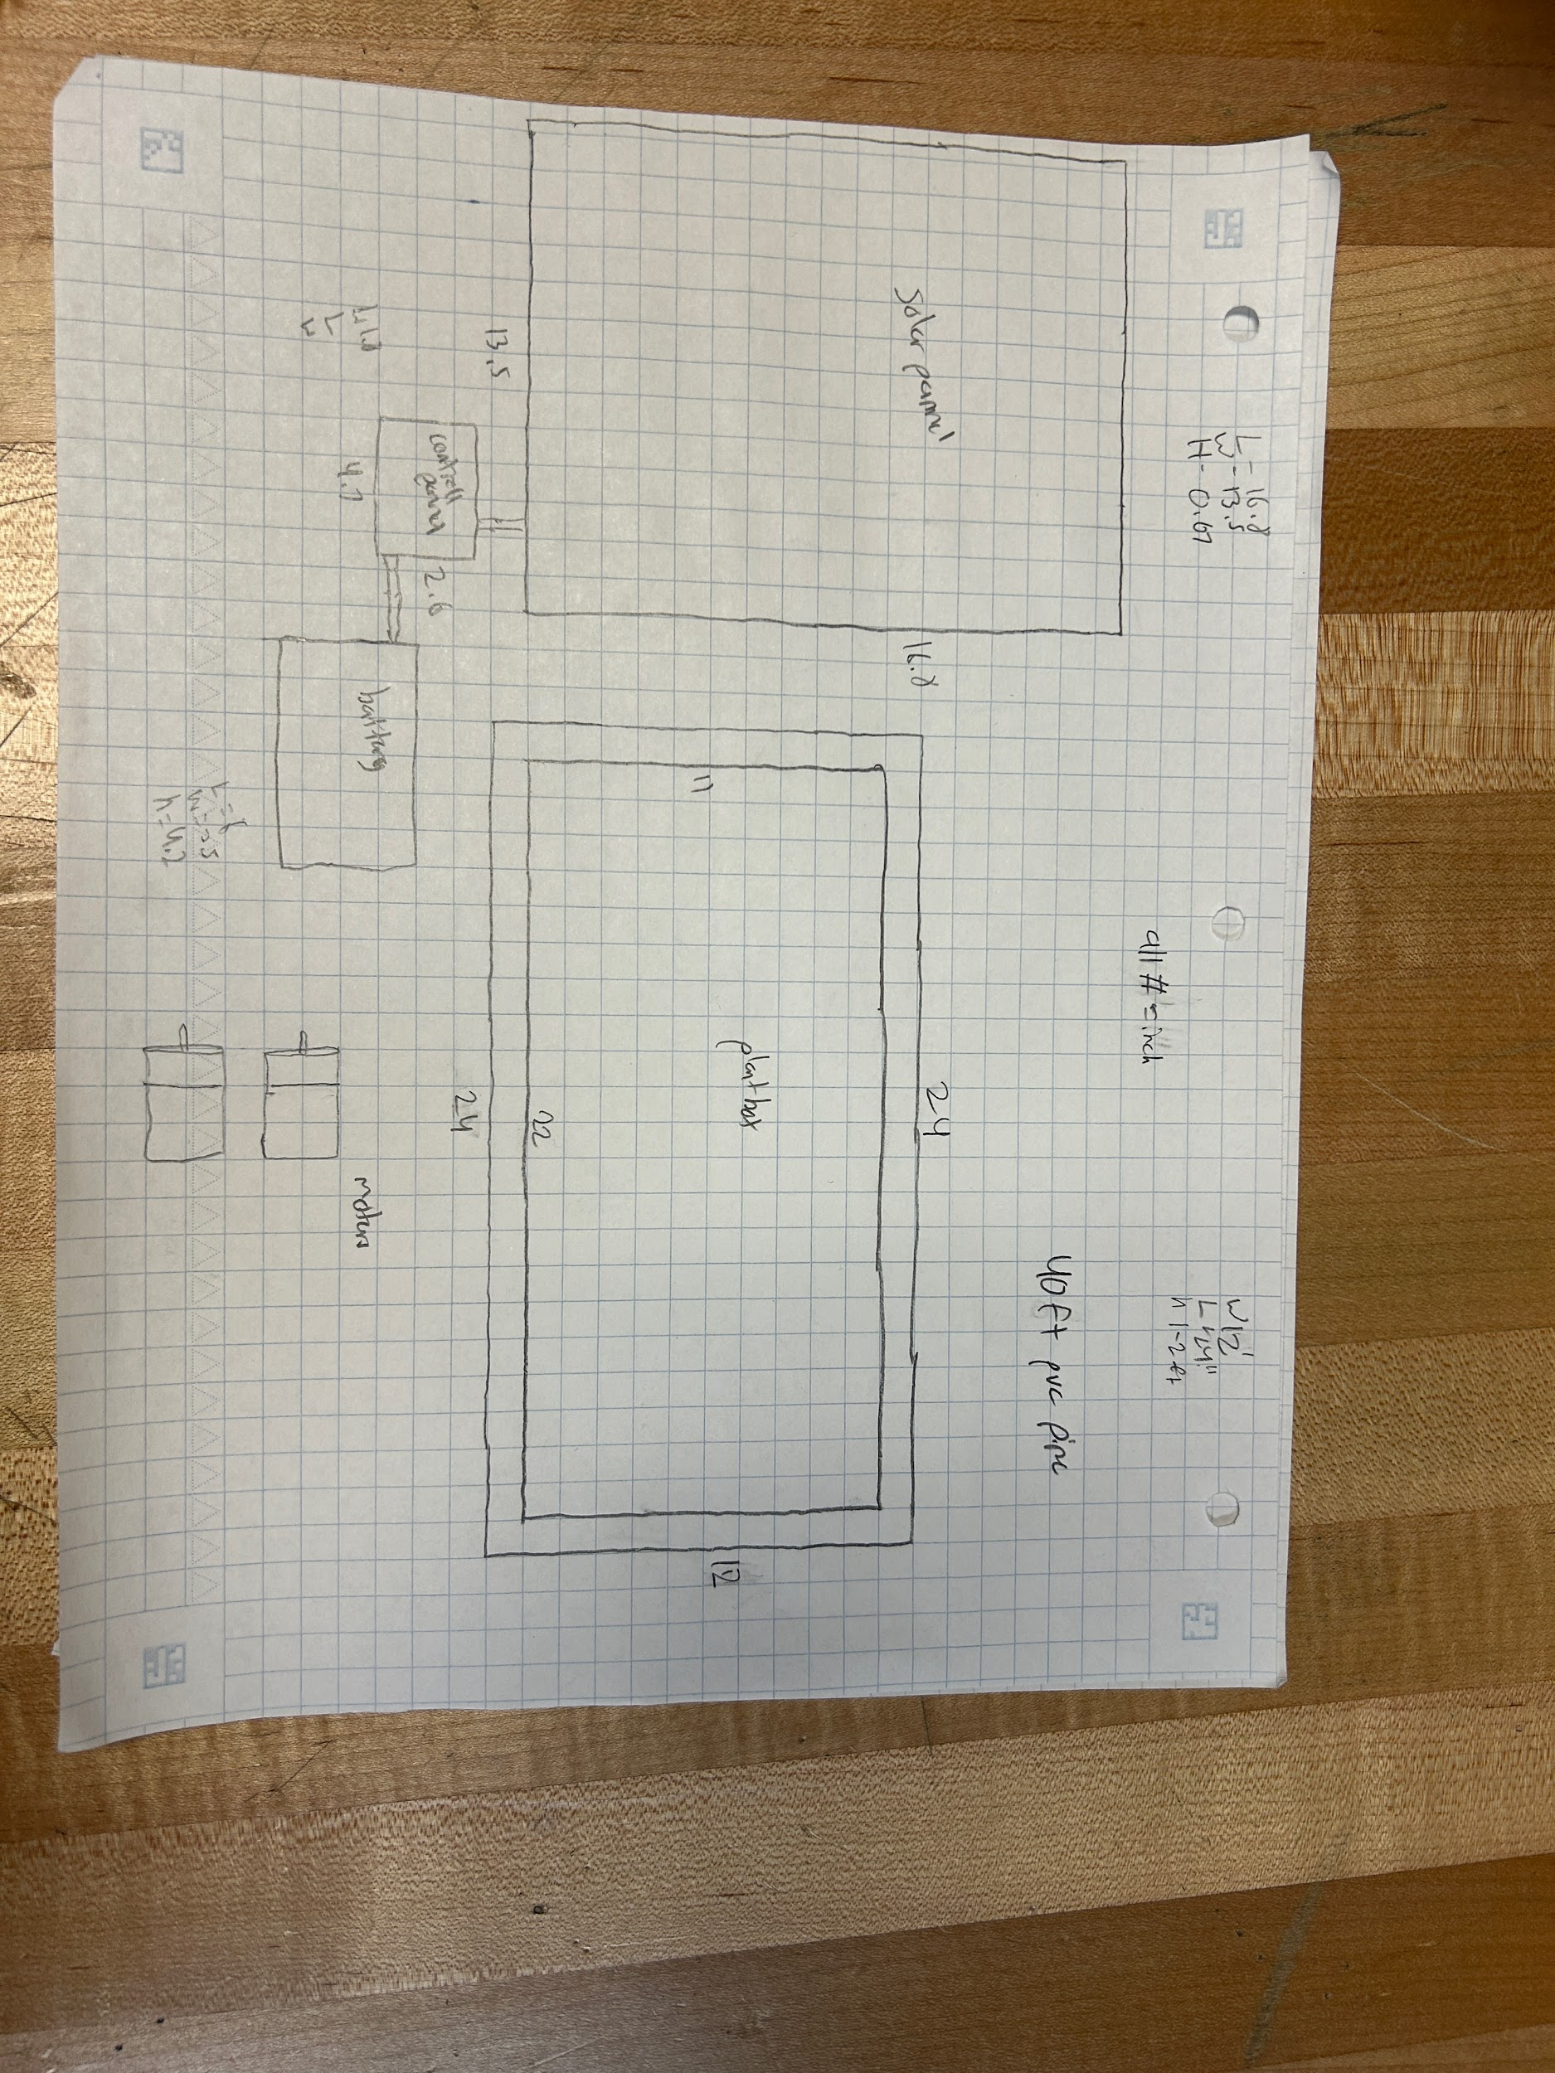
Manufacturing Methods:
Step 1:Make legs and make the base that will hold the shade cloth above the plant.
Step 2: Place the plant box in the base made the start hooking up the solar panel
Step 3:Connect the solar panel to the battery
Step4: connect the mash netting to the pipe to roll it up
Step5:connect the sensors to the battery
Supply List and Costs:
Item | Cost each | # needed | Total
Motor | $15.00 | 1 | $15.00
Battery | $12.00 | 1 | $12.00
Fabric | $6.00 | 1 | $6.00
Timer | $12.00 | 1 | $12.00
PVC pipe | $3.00 | 12 | $36.00
PVC elbow | $3.75 | 8 | $30.00
Zip ties | $0.05 | 20 | $1.00
Total Cost | $51.80 | 43 | $112.00

